https://platformio.org/install/ide?install=vscode

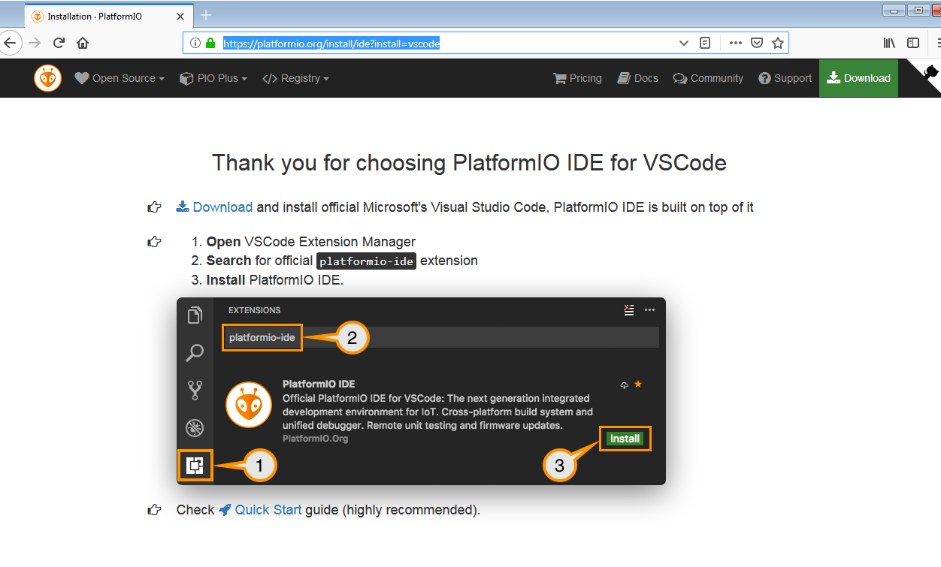
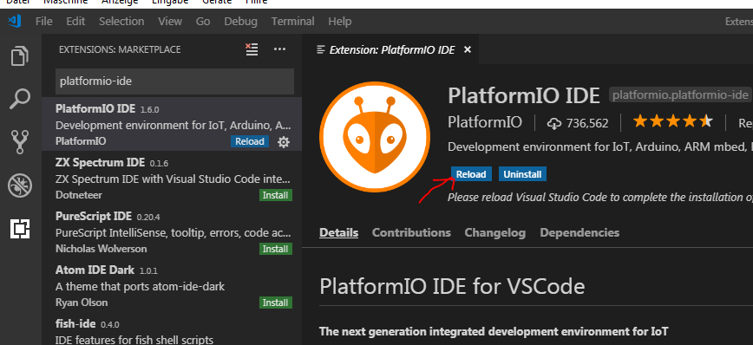
Reload .. Wait… Reload,

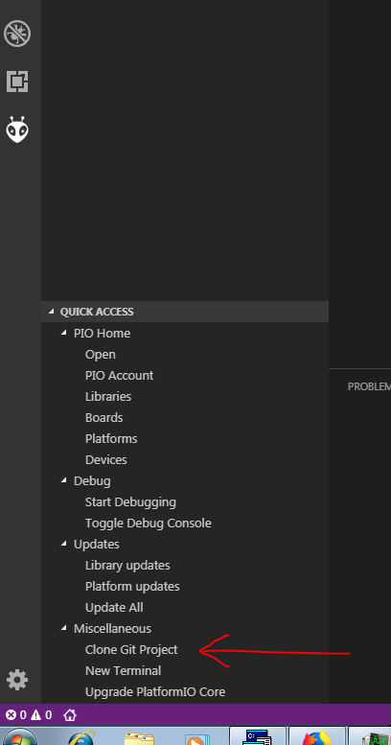

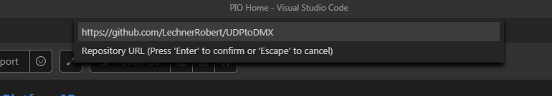
https://github.com/LechnerRobert/UDPtoDMX

to „My Documents\PlatformIO\Projects“

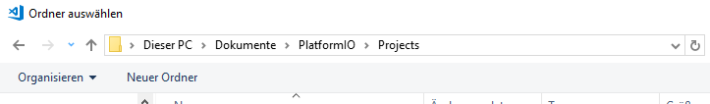

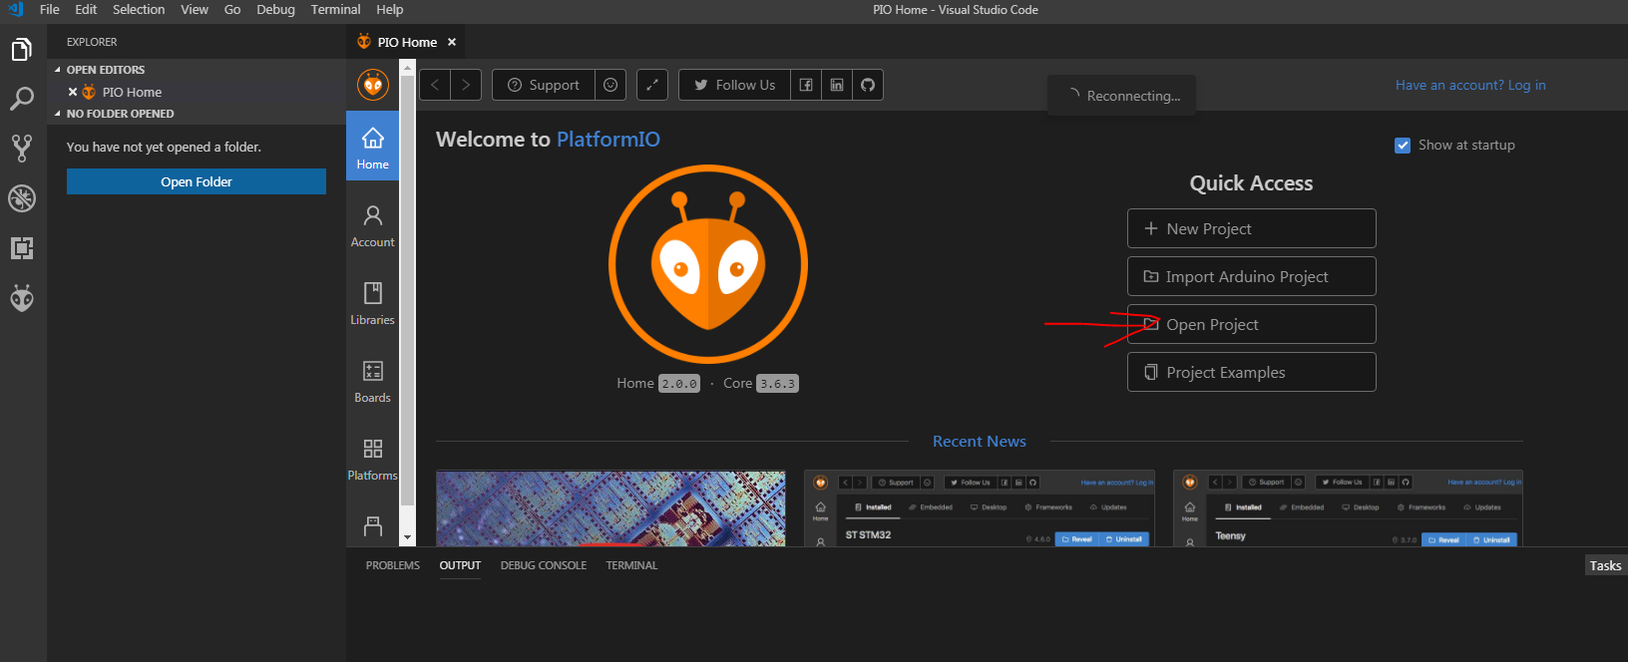

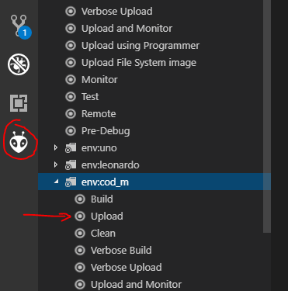

optional install git and tortoisegit:

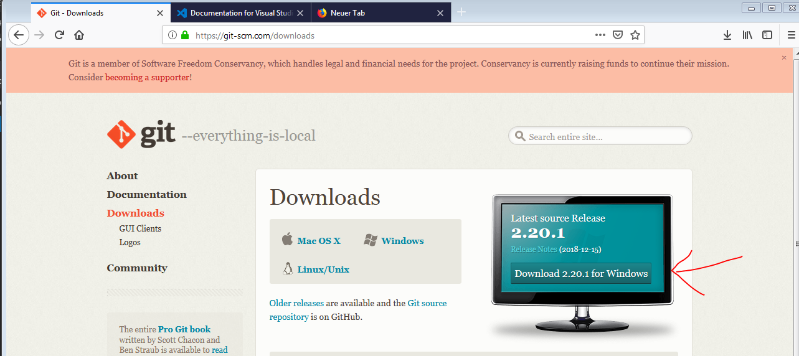
and

https://tortoisegit.org/

